**PROJECT TITLE:Enhancing Road Safety with AI-Driven Traffic Accident Analysis and Prediction**

**PHASE 3**

**STUDENT NAME : THIRUMALAI G**

**REGISTER NUMBER: 620523243057**

**INSTITUTION :CMS COLLEGE OF**

**ENGINEERING,**

**NAMAKKAL.637003**

**DEPARTMENT :B.TECH- ARTIFICIAL**

**INTELLIGENCE AND**

**DATA SCIENCE**

**DATE OF SUBMISSION:**

**GITHUB REPOSITORY**

**LINK :**

**1. Problem Statement:**

Road accidents pose a significant threat to life and property in Salem, Tamil Nadu, India. The increasing number of vehicles and complex traffic patterns contribute to a concerning rise in collisions, resulting in injuries, fatalities, and economic losses. Traditional methods of road safety management often rely on reactive measures and static analyses, which may not effectively address the dynamic and multifaceted nature of traffic accidents. There is a pressing need for proactive and data-driven solutions that can analyze historical accident data, identify high-risk factors, and predict potential accident hotspots to enable timely interventions and ultimately enhance road safety for the citizens of Salem.

**2. Abstract:**

This project aims to develop an AI-driven system for traffic accident analysis and prediction in Salem, Tamil Nadu. By leveraging historical traffic accident data, advanced machine learning techniques will be employed to identify key contributing factors and predict the likelihood of accidents in specific locations and timeframes. The project will involve data collection, preprocessing, exploratory data analysis, feature engineering, model building (classification and/or regression), rigorous model evaluation, and visualization of results. The insights gained from this analysis will provide valuable information for traffic authorities to implement targeted safety measures, optimize resource allocation, and ultimately reduce the occurrence and severity of road accidents in Salem.

**3. System Requirements:**

* **Software Requirements:**
  + Operating System: Windows/Linux/macOS
  + Programming Language: Python (version 3.x)
  + Data Analysis and Machine Learning Libraries: Pandas, NumPy, Scikit-learn, Matplotlib, Seaborn
  + Database (Optional for large datasets): SQLite, PostgreSQL, MySQL
  + Geospatial Analysis Libraries (if applicable): GeoPandas, Folium
  + Deployment Platform (if applicable): Flask, Django, cloud platforms (e.g., AWS, Google Cloud, Azure)
* **Hardware Requirements:**
  + Sufficient RAM (at least 8 GB recommended)
  + Adequate storage space for datasets and models
  + Processor with decent computational power

**4. Objectives:**

* To collect and curate a comprehensive dataset of historical traffic accidents in Salem, including relevant features such as location, time, road conditions, vehicle types, and involved parties.
* To preprocess the collected data by handling missing values, cleaning inconsistencies, and transforming it into a suitable format for analysis.
* To conduct exploratory data analysis (EDA) to understand the underlying patterns, distributions, and relationships within the accident data.
* To engineer relevant features from the existing data that can improve the predictive power of the AI models.
* To develop and train appropriate machine learning models (e.g., classification for predicting accident occurrence, regression for predicting accident severity) using the processed data.
* To rigorously evaluate the performance of the developed models using appropriate metrics and validation techniques.
* To visualize the analysis results and model insights in a clear and understandable manner for stakeholders.
* (Optional) To explore potential deployment strategies for the developed model to provide real-time or near real-time predictions.

**5. Flowchart of the Project Workflow:**

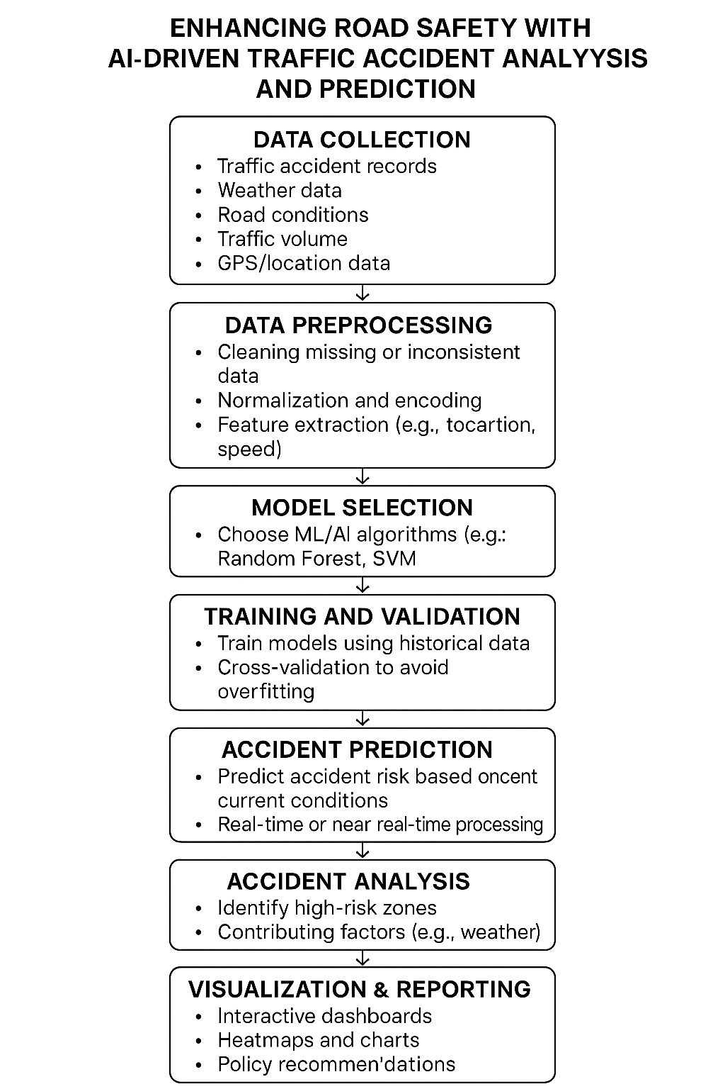

**6. Dataset Description:**

This section will detail the dataset(s) used in the project. Include information such as:

* **Source(s) of Data:** (e.g., Local Traffic Police Department records, government databases, news reports if relevant and accessible, simulated data if real data is limited initially).
* **Timeframe of Data:** Specify the period covered by the data.
* **Number of Records:** Indicate the size of the dataset.
* **Key Variables:** List and describe the important features available in the dataset. Examples might include:
  + Accident ID
  + Date and Time of Accident
  + Latitude and Longitude of Accident Location
  + Road Type (e.g., highway, local road)
  + Road Conditions (e.g., dry, wet, icy)
  + Lighting Conditions (e.g., daylight, darkness with streetlights)
  + Weather Conditions (e.g., clear, rainy, foggy)
  + Type of Vehicles Involved
  + Number of Vehicles Involved
  + Number of Casualties (Injured/Fatalities)
  + Age and Gender of Involved Parties (if available)
  + Cause of Accident (if recorded)
* **Data Format:** (e.g., CSV, Excel, database tables)
* **Potential Challenges:** (e.g., missing data, inconsistencies, data privacy concerns)

**7. Data Preprocessing:**

This section will outline the steps taken to prepare the data for analysis and modeling:

* **Data Cleaning:**
  + Handling missing values (imputation or removal).
  + Identifying and correcting inconsistencies or errors in the data.
  + Removing duplicate records.
* **Data Transformation:**
  + Converting data types as needed (e.g., converting date/time strings to datetime objects).
  + Encoding categorical variables (e.g., using one-hot encoding or label encoding).
  + Scaling or normalizing numerical features (e.g., using Min-Max scaling or standardization).
* **Data Integration (if using multiple datasets):**
  + Merging or joining datasets based on common keys.
* **Handling Outliers:**
  + Identifying and addressing potential outliers.

**8. Exploratory Data Analysis (EDA):**

This section describes the techniques used to gain insights from the data:

* **Descriptive Statistics:** Calculating measures like mean, median, standard deviation, and quartiles for numerical features.
* **Data Visualization:** Creating various plots to understand data distributions and relationships:
  + Histograms and box plots for numerical features.
  + Bar charts and pie charts for categorical features.
  + Scatter plots to explore relationships between numerical variables.
  + Heatmaps to visualize correlations between features.
  + Geospatial visualizations (e.g., using Folium) to identify accident hotspots on a map of Salem.
  + Time series plots to analyze trends in accident occurrence over time.
* **Identifying Patterns and Trends:** Analyzing the visualizations and statistics to uncover significant patterns, correlations, and trends related to traffic accidents.

**9. Feature Engineering:**

This section details the creation of new relevant features from the existing data:

* **Temporal Features:** Extracting features from the date and time of the accident, such as:
  + Day of the week
  + Month of the year
  + Hour of the day
  + Weekend/weekday indicator
  + Holiday indicator (if applicable)
* **Spatial Features:** Deriving features from the location data (if detailed enough):
  + Identifying high-risk zones or intersections.
  + Calculating distances to nearby points of interest (e.g., schools, hospitals, markets).
* **Interaction Features:** Creating new features by combining existing ones that might have a combined effect on accident occurrence or severity (e.g., combining road condition and weather condition).
* **Lag Features (if time-series analysis is a focus):** Creating features based on past accident occurrences in a specific location or time period.

**10. Model Building:**

This section specifies the AI/Machine Learning models to be used:

* **Model Selection:** Justify the choice of models based on the problem type (classification for predicting accident occurrence, regression for predicting severity) and the characteristics of the data. Potential models include:
  + **Classification:** Logistic Regression, Support Vector Machines (SVM), Decision Trees, Random Forests, Gradient Boosting (e.g., XGBoost, LightGBM), Neural Networks.
  + **Regression:** Linear Regression, Support Vector Regression (SVR), Decision Trees, Random Forests, Gradient Boosting (e.g., XGBoost, LightGBM), Neural Networks.
* **Model Training:** Describe the process of training the selected models using the preprocessed and engineered features. This includes splitting the data into training and testing sets.
* **Hyperparameter Tuning:** Explain how you will optimize the model parameters to achieve the best performance (e.g., using techniques like GridSearchCV or RandomizedSearchCV).

**11. Model Evaluation:**

This section outlines how the performance of the trained models will be assessed:

* **Evaluation Metrics (for Classification):**
  + Accuracy
  + Precision
  + Recall
  + F1-score
  + AUC-ROC curve
  + Confusion Matrix
* **Evaluation Metrics (for Regression):**
  + Mean Absolute Error (MAE)
  + Mean Squared Error (MSE)
  + Root Mean Squared Error (RMSE)
  + R-squared
* **Cross-Validation:** Explain the use of cross-validation techniques (e.g., k-fold cross-validation) to ensure the robustness and generalizability of the models.
* **Comparison of Models:** If multiple models are built, describe how their performance will be compared to select the best one(s).

**12. Deployment (Optional):**

This section would describe potential ways to deploy the developed model:

* **Web Application:** Creating a user-friendly web interface where traffic authorities can input relevant parameters and get predictions or visualize risk maps.
* **API Integration:** Integrating the model into existing traffic management systems via an API.
* **Dashboard:** Developing an interactive dashboard to display accident statistics, risk predictions, and key insights.
* **Mobile Application:** Creating a mobile app to provide real-time risk assessments or report potential hazards.

**13. Source Code:**

This section would typically involve providing access to the code developed for the project (e.g., hosted on GitHub or included as appendices).

**14. Future Scope:**

This section outlines potential extensions and improvements for the project:

* **Real-time Data Integration:** Incorporating real-time traffic data (e.g., from sensors, cameras) to improve prediction accuracy.
* **Integration of External Factors:** Including data on socio-economic factors, road infrastructure changes, or public events that might influence traffic accidents.
* **Developing Explainable AI (XAI) Techniques:** Making the model predictions more interpretable for better understanding and trust.
* **Predicting Accident Severity:** Focusing on predicting the severity of accidents to prioritize emergency response.
* **Driver Behavior Analysis:** Incorporating data related to driver behavior (if available) to enhance prediction capabilities.
* **Developing Intervention Strategies:** Suggesting specific safety interventions based on the model predictions.

**15. Team Members and Roles:**

If this is a team project, list each member and their specific contributions and responsibilities. For example:

* **[Team Member Name 1]:** Role (e.g., Data Collection & Preprocessing Lead)
* **[Team Member Name 2]:** Role (e.g., Model Building & Evaluation Specialist)
* **[Team Member Name 3]:** Role (e.g., Visualization & Reporting)

Once you have fleshed out the details for each of these sections based on your specific project in Salem, I can help you review and organize it further. Let me know when you're ready to elaborate on any of these points!